Hello and welcome to the SciCrisp project!

If you are reading this then you are a new author of our project. We are really happy that you expressed your interest in working with us and sharing your research with the broader public!

What is SciCrisp anyway?

**SciCrisp is a new format of scientific writing, where researchers review their recently published article/thesis in a fun and approachable way for scientists and the general public.**

Why are we doing this?

**Curiosity**. Everyone is curious about the world around us, however, the complexity and topic-specificity of science kill it for people outside the field.

Wouldn’t it be amazing if everyone can **just open, read and enjoy** a scientific text? Actually, for every paper, every presentation, and every thesis there is at least one person who already explained everything themselves: **the researcher**. SciCrisp is the next step, where scientists **tell a story about their research and discoveries directly** to the broader audience.

How? **Let’s move on from abstract ideas to the practical parts.**

SciCrisp has a fixed format, but inside each section you have a lot of freedom and flexibility!

| **Yes, you can!**  -Use metaphors.  -Use appropriate slang, songs lyrics lines, idioms.  -Write in 1st, 2nd, or 3rd person.  -Write a section as a story as long as it has a strong and relevant link to your topic.  -Transform subjects or objects of your research to characters.  -Describe feelings or actions that happen during the research/experiments/discoveries.  -Show more of the contribution of the researcher. At the end there is a person behind the research.  -Use memes and jokes related to your field.  -Use funny visualization.  -Engage readers to move or do something which helps to understand the topic more. | **You’d better not:**  -Be rude.  -Discriminate.  -Use inappropriate words  -Use bad jokes.  -Write bad comments about other papers/scientists etc.  -Violate the law.  -Use jargon. |
| --- | --- |

**STYLE SHEET**

* Spelling: please use British English spelling.
* Numbers: spell out numbers zero through ten and use numerals thereafter.
* Word count standard 1500-1700 (2000 max) words without header and references. Of course, it can be shorter as long as it includes all the necessary information.
* Acronyms: always write the full name in the first mention with the acronym in parenthesis. Further mentions can use the acronym directly.
* Citing:
  + We use hyperlinks instead of citations.

Example:

At the same time [heat shock accelerates the splicing process](https://www.sciencedirect.com/science/article/pii/S1097276503003101), so ‘splicing control’ proteins just do not have time for dealing with cassette exons and therefore exclude them from a sequence.

* + At the end of the Links section you also can write in a free form sources which you didn’t mention in text but you think they could be interesting for a reader.
* Highlight the most important bits. You can choose any way to highlight the most important words/sentences as long as it looks clear visually and does not disorient readers. (bold/italic/underlining/color highlighting)

**Example of bad highlighting:**

**PV** is harmless to humans, as it doesn’t bite and (luckily) doesn’t spread illnesses. So **why** should we continue to study desiccation processes in this species**?** Because it is a fascinating adaptation skill and knowing the underlying processes *could be used in agriculture and medicine*, for example, in biomaterials storage. Just imagine, one day it could replace liquid nitrogen! **Instead of unfree**zing your samples, you can take a handful of dehydrated cells or tissues and just add water, as simple as instant noodles cooking.

**Example of good highlighting:**

PV is harmless to humans, as it doesn’t bite and (luckily) doesn’t spread illnesses. So **why** should we continue to study desiccation processes in this species**?** Because it is a fascinating adaptation skill and knowing the underlying processes **could be used in agriculture and medicine**, for example, in biomaterials storage. Just imagine, one day it could replace liquid nitrogen! Instead of unfreezing your samples, you can take a handful of dehydrated cells or tissues and just add water, as simple as instant noodles cooking.

Visualization:

* Pictures: as long as they are CC copyright or your own.
* Figures: as long as permission to reproduce is from a published article or your own.
* Sometimes scientific images could be hard to understand for the common reader, so we recommend:
  + Split complicated plots into several panels and explain them separately.
  + Doodle right on the plot. Yes, in SciCrisp you can do it.
  + Create a schematic explanation of processes, theories, etc.

Here are some examples for whose creation I used only google drawing (Scribble, shape and text function):

Example #1: using the original image and adding some arrows to highlight the direction of changes and text to explain the axis. When you use the original image, please add ‘Figure was adapted from the original manuscript/article.’ at the end of the figure description.

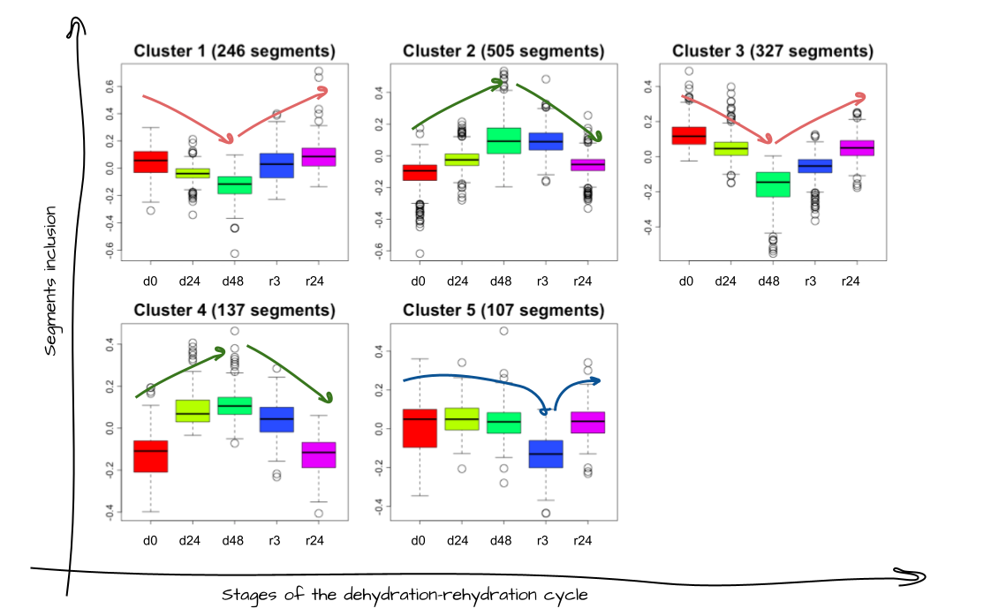

Example #2: create schema from a scratch which explains the alternative splicing concept

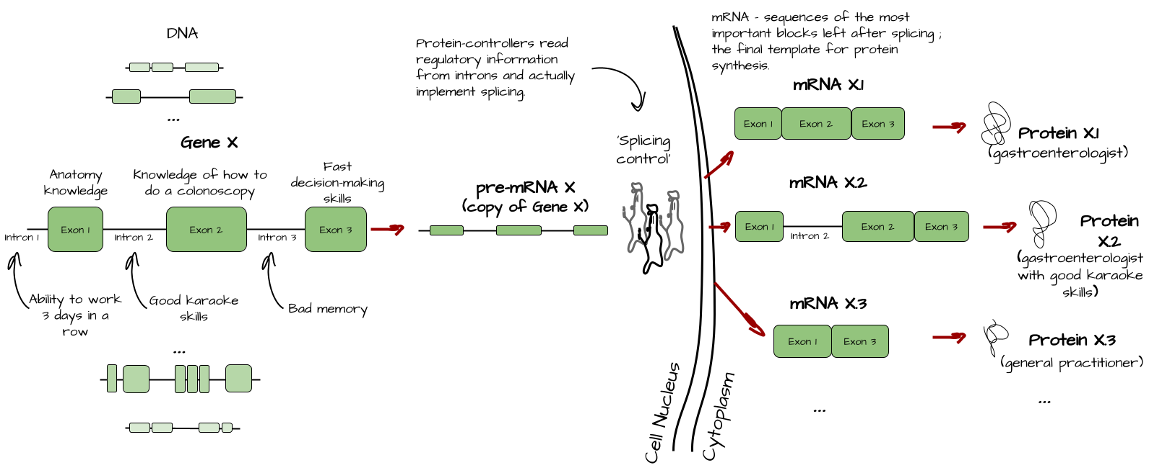

* + For visualization you also can use Photoshop, BioRender, Canva, Powerpoint, InkScape, etc.
* Caption under the visuals should include:
  + What this picture is about.
  + Abbreviations meaning if you used some on your figure
  + ‘Figure adapted from the original manuscript/article. ’, if you used the original figure or changed it with doodling or something else.
* Also you can mention it in the text as Figure X or Fig. X.

**For example:**

…I separated the segment groups by 5 patterns based on the behavior of their inclusion/exclusion from the mRNA. (Fig 3) …



Figure 3. Patterns of segments inclusion/exclusion during the dehydration-rehydration cycle. Figure was adapted from the original manuscript.

If you still feel confused, just **scroll down** and look at the **template of the SciCrisp** format with small descriptions of each section. **Everything will become clear after that!**

“I'm a funny/intriguing title with a hint on what this text will be about”

**A fun and approachable review** of research: *citing to original article/thesis*

By *Writor’s Name and Surname*

| *Put here a funny/intriguing image somehow connected with your research. The whole point of this table is to make the reader open the review and read it, so we need to leave as many interesting ‘hooks’/clues/questions/etc as we can. Think about this: Why should someone be interested in your research? What problem does it solve? What issue does it connect to that they would care about?*  The SciCrisp team will create it, so it suits the TSB style. | Questions will be answered:  * *Imagine that you are a reader who just saw the title. What question can pop up in the reader's head? Will you answer them in your review? If yes, write them here.* * *Here* * *Here* * *And here…* |
| --- | --- |

# Prequel of the research

# *The major point of this part is to answer the question:* ***Why should readers care about the problem or subject, and what do they need to know for understanding your results?*** *Are there previous discoveries in the field or is there a new theory/hypothesis or are there some processes/mechanisms obvious for researchers but not for non-scientist? You can describe them here.*

*But it is also the part where the* ***reader will be introduced to the research area in general and to you as an author****. You can write why you joined this project, what is so fascinating about it? How can it affect readers' lives or society? Or whatever you want to tell readers about you and your story in this research.*

***In SciCrisp you have more freedom!*** *You can use metaphors and compare complicated processes with something very casual. You can write in 1st, 2nd or 3rd person. You can transform your objects (humans, animals, molecules, equipment, anything else) into the story's main characters. You can tell stories from your/others' life that support your ideas in the text. You can even joke here (politely).*

*In the end, only* ***you know*** *what the reader needs to know to understand you and your research better, we can only help you in this process.*

| Some subtitle in a nutshell *We suggest the ‘In a nutshell’ section for those cases when you are describing something obvious in your field, which can be boring for researchers, but very important to understand for the broader public. It will be a drop down section, so you can describe something here and it will not bother readers who already know this.* |
| --- |

# Nice plots and what do they really mean

*Screw the method section, let’s go to the most interesting part, results! No,* ***the most interesting results****! You don’t have to describe all plots from your research. What are the most essential results and plots supporting them? What do they really mean? What question can you answer based on them? What additional questions appear after you receive the plot?*

*If the plot is too complicated to understand, we suggest* ***doodling****. I used just google drawing to add some arrows, sketches and explanations right on the plot.*

# Take-home messages

1. *List of conclusions/tidbits that you want readers to pay attention for and maybe even take home and tell their friends.*
2. *Go back to the table ‘Questions will be answered’. Did you answer them in your text? If yes you can highlight answers here. If no, you may want to rethink either the list of questions at the beginning or add the answers in the text.*
3. *Ram*
4. *Pam Pam*

# Links

Original thesis/article:

*Link to the original article or thesis*

Could be interesting to read:

*Additional sources which you didn’t mention in the text, but can be interesting to readers.*

—-----------------------------------------the end----------------------------------------------------

If anything is still unclear or you have any questions, please drop us a line at blogging@thesciencebasement.org